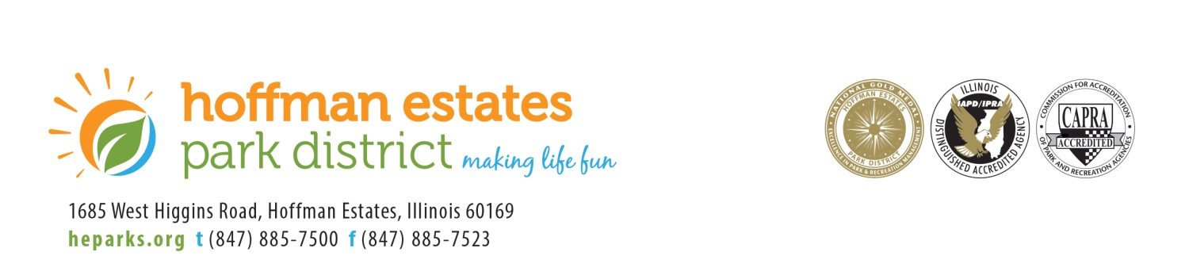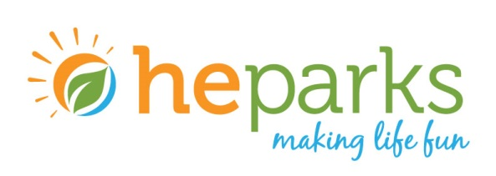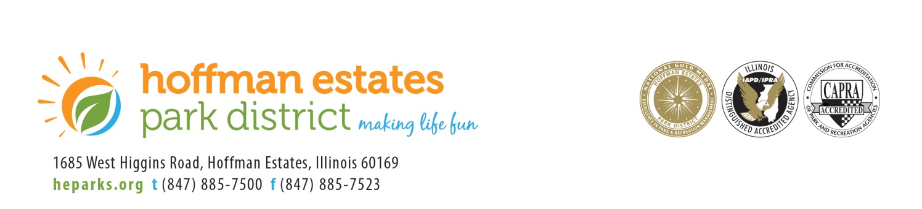

The mission of the Hoffman Estates Park District is to offer healthy and enjoyable experiences to our residents and guests by providing first class parks, facilities, programs and services in an environmentally and fiscally responsible manner.

**AGENDA**

**SPECIAL BOARD MEETING**

**TUESDAY, JANUARY 21, 2020**

**IMMEDIATELY FOLLOWING 7:20PM RECREATION COMMITTEE MEETING**

1. ROLL CALL
2. PLEDGE OF ALLEGIANCE
3. APPROVAL OF AGENDA
4. COMMENTS FROM THE AUDIENCE
5. APPROVAL OF SOUND PANELS AT THE CLUB / M20-008

6. COMMISSIONER COMMENTS

7. ADJOURNMENT