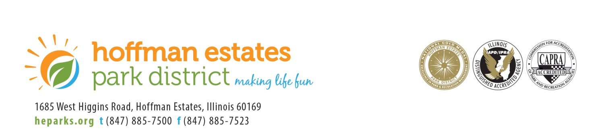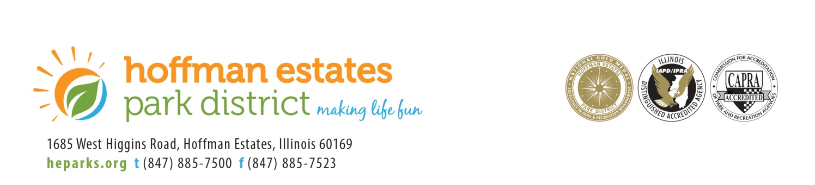

The mission of the Hoffman Estates Park District is to offer healthy and enjoyable experiences to our residents and guests by providing first class parks, facilities, programs and services in an environmentally and fiscally responsible manner.

***Cancellation***

**BUILDINGS & GROUNDS COMMITTEE MEETING**

**RECREATION COMMITTEE MEETING**

**TUESDAY, NOVEMBER 19, 2019**

The Building & Grounds Committee Meeting has been cancelled due to a lack of business. The next meeting is scheduled for December 10, 2019.

The Recreation Committee Meeting has been cancelled due to a lack of business. The next meeting is scheduled for December 10, 2019.

All meetings are held in the boardroom of the Scott R. Triphahn Community Center & Ice Arena at 1685 W. Higgins Road in Hoffman Estates, unless otherwise specified. If an accommodation or modification is required to attend this public meeting please call 847-885-7500 with at least 48 hours’ notice.